1. Draw a labeled diagram of a desktop PC, clearly marking the motherboard, CPU, RAM, GPU, and both HDD and SSD storage components.
ANS:
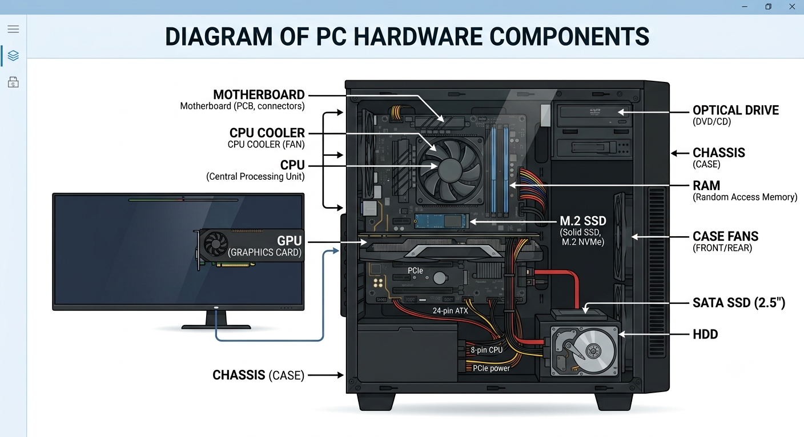
- Create a comparison table showing the main differences between HDD and SSD storage in terms of speed, durability, and typical use cases.<br><br><em><strong>Hint:</strong> Think about which one is faster, which is more shock-resistant, and where you would usually find each type (laptop, gaming PC, etc.).</em>
ANS :
FEATURE | HARD DISK DRIVE | SOLID STATE DRIVE
Speed | Slow er (Read/Write speeds).Uses spinning mechanical platters and read/write head. | Much faster.Uses flash memory with a moving parts.
Durability and Shock Resistance | Lower durability against physical drops and movement because of fragile mechanical moving parts. | Higher shock resistance and durability since there are no moving parts to break or misalign if dropped.
Typical Use Cases | Mass storage, large data backups, budget desktops, and enterprise servers where high capacity per dollar is prioritized. | Operating system drives, modern laptops, gaming PS’s, high performance workstations, and fast game loading.

- Write a short explanation (2-3 sentences each) describing the role of the CPU, RAM, and GPU in running a game like PUBG or Free Fire on a PC.

ANS : 1. CPU (Central Processing Unit)
Often called the "brain" of the computer, the CPU handles the game's core logic, physics, artificial intelligence, and overall game rules. In a fast-paced battle royale game, it continuously calculates player movements, gunshots, and interactions with the environment, telling the rest of the system what is happening.

2. RAM (Random Access Memory)
RAM acts as the computer's short-term working memory, storing active game data—such as map details, player skins, and audio files—for instant access. Having enough RAM ensures the game loads quickly and runs smoothly without stuttering while swapping data between the storage drive and the processor.

3. GPU (Graphics Processing Unit)
The GPU is responsible for rendering the visual world, turning raw data into the detailed 3D graphics, textures, lighting, and special effects you see on screen. For demanding games, the GPU works at high speeds to draw dozens or hundreds of frames per second, ensuring smooth and immersive gameplay.
- Imagine you want to upgrade your PC to run the latest version of FIFA smoothly. List which hardware components you would consider upgrading and explain why for each.
ANS : • GPU (Graphics Card): Renders player models, stadiums, and lighting for smooth, high-frame-rate visuals.
• CPU (Processor): Manages real-time ball physics and advanced AI for all 22 players on the pitch.
• RAM (Memory): Ensures fast asset loading and prevents stuttering during matches (16GB recommended).
• SSD (Storage): Drastically cuts down match loading times and eliminates texture pop-in.

